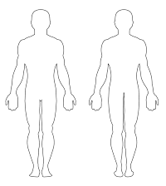
5 Questions to challenge yourself?
- If you were to do a squat, what muscle are you working the hardest?
- Which of these muscles on your body is the largest?
- What is one type of exercise you can do to improve your strength of your abdominals?
CALVES
TRICEPS
HAMSTRINGS
GLUTES
BICEPS
QUADRICEPS
ABDOMINALS
PECTORIALS
DELTOIDS
LATS
TRAPEZIUS
GROINS
BACK
FRONT
S4A P.E
PIN THE MUSCLES ON THE BODY

