

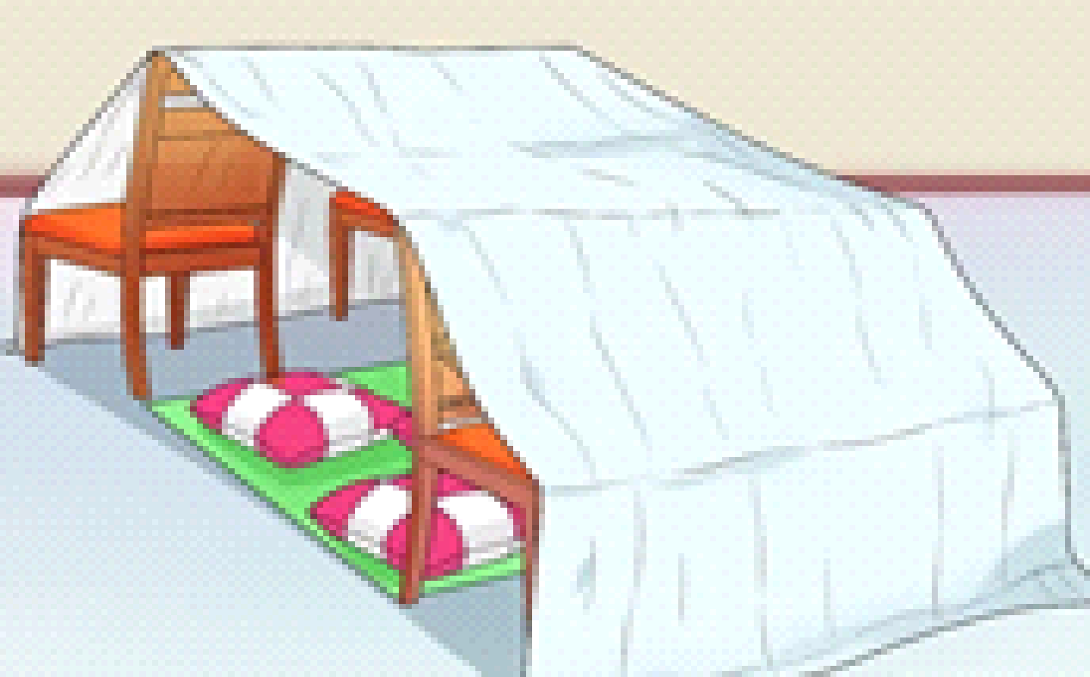

Challenge!!!
Create a den with an emergency escape route
Stay at Home P.E

What we are looking to achieve:
To be creative and think of cool ideas!
To see if you can build a big den with reasons why we built it how you did

Warm Up
Collect all items needed from around the house e.g. blankets, bed sheets, cushions, chairs…
The Build!

- Spread out the chairs evenly (Can use back of sofas as well)
- Lay out cushions and blankets on the ground
- Use large bed sheet and throw over the sheet, hold down with books and pegs.
- Have fun and chill out in the den

Cool Down
Tidy up all items used and return everything to where they belong.
Fold up and put away blankets and beds heets.

Be creative and experimental with your den build!

