Stay at Home P.E
Scavenger Hunt

Tick in the circle once you have completed that item!
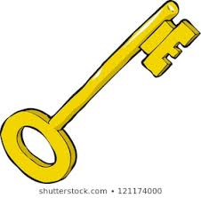
- Find a table spoon
- Find a fluffy blanket
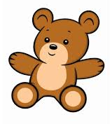
- Find a blue jumper
- Find a rubber band
- Find a colourful flower
- Find a key
- Find 3 different types of Teddies
- Find a plaster
- Find a box of cereal

- Find a clothes hanger
- Find a tube of tooth paste
- Find a broom or dust pan and brush
- Spot a flying bird outside
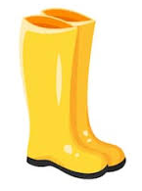
- Find a pair of matching socks
- Find a toilet roll
- Find a hairband
- Spot a runner or cyclist going past your home
- Find a welly
- Find 2 different types of cushions
- Find something red that is bigger than your head
- Find a sticker

- Find a coin
- Find something from a family trip or holiday
- Find your favourite item in your home

