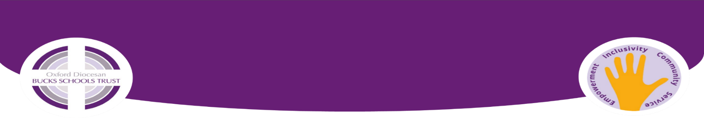
Oxford Diocesan Bucks Schools Trust (ODBST)
Empowering lives, flourishing together
We aspire for every pupil and adult to ‘experience life in all its fullness’ (John 10:10)
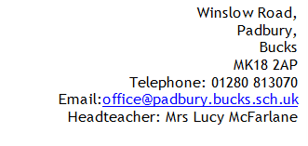

Wednesday 4th February
Dear Parents,
Thank you to everyone who took the time to share their views as part of our recent consultation regarding the proposal to introduce a two-week October half-term break.
Following careful consideration of the feedback received, we can confirm that the ODBST will be moving forward with the introduction of a Trust-wide two-week October half-term, beginning in the 2026/2027 academic year.
We are grateful for the thoughtful responses and engagement shown throughout the consultation process. Your contributions have been invaluable in helping us make an informed decision that supports pupil wellbeing, attendance, and staff sustainability. Thank you for your continued support of our school community and the ODBST.
At Padbury, the INSET days for the teachers will be:
Tuesday 1st September
Friday 30th October
Friday 4th June

These dates sit within the school holiday so do not affect the 190 days the children attend school. Teachers need 5 INSET days or equivalent hours of training across a year so the other two days (12 hrs) will split across each half term, 2 hrs every half term in addition to the staff meetings staff attend weekly in order to maintain key health and safety and safeguarding training.
Yours sincerely,
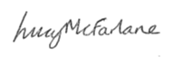 SPiesse
Lucy McFarlane Mrs Sulina Piesse,
Headteacher Chief Executive Officer, the ODBST

