

Padbury CE School Newsletter Spring Term 2026

Issue 4 28th January 2026
Our value this half term is Courage

"So in everything, do to others what you would have them do to you” Matthew 7:12

Parent Consultation Evenings
As you know, parent consultation meetings will be taking place on Wednesday 11th February and Thursday 12th February this term. These meetings will be for children in Beech, Oak and Sycamore class. Appointments for these will go live on Friday this week. Meeting with Mrs Grace for Maple class will take place after half term on Tuesday 3rd March and Thursday 5th March and appointments for those will go live on MCAS after half term.

Young Voices 2026
Wow! Another amazing night last night at Young Voices. The children had an absolute ball and the videos I have seen show me how much it meant to them all. The children were brilliantly behaved, represented the school beautifully and I am incredibly proud of them and the staff for being so keen to give up time to allow the children to have this experience. Thank you to Mrs Grace for organising the event, Mrs Mackenzie for leading the visit and other staff for attending to enable the visit to go ahead.
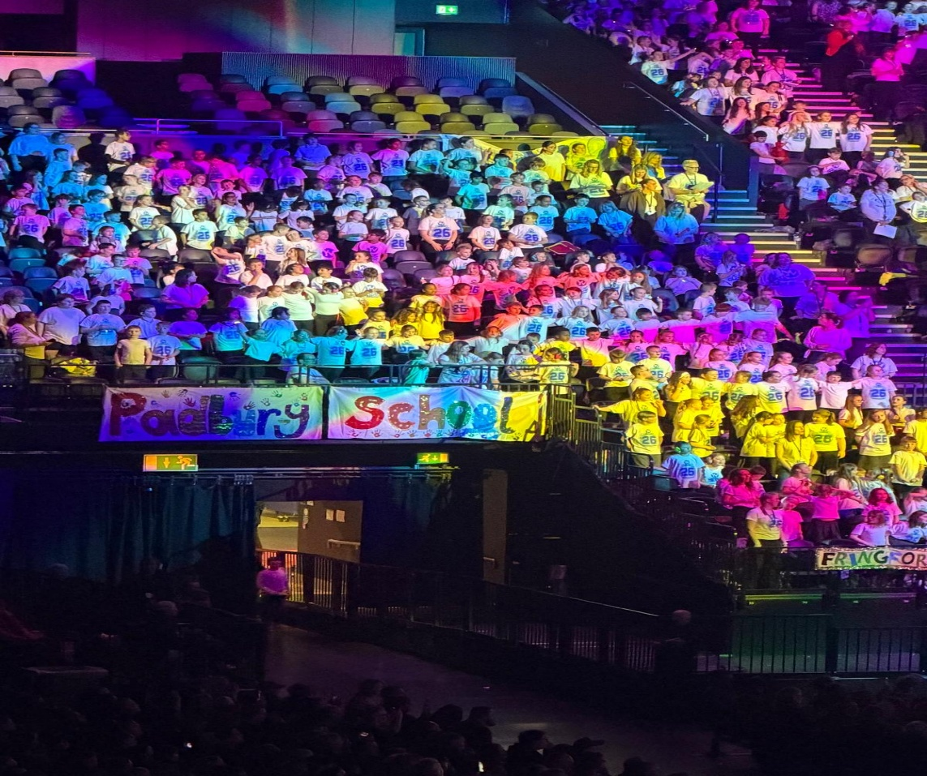
We have made the decision that this will now become a two-yearly event following feedback from parents in the last year's survey. This will mean each child will be able to go twice in KS2 if they wish. The experience is not compulsory! We feel this keeps the occasion exciting and something to look forward to without costing money for parents every year and the novelty of going becoming less exciting.

Spellathon
I hope by now the children have chosen which spellings they are working on learning for their spellathon during the week beginning 6th February and are working hard on remembering as many as they can . Little and often is the best way for the spellings to be retained. The best way of remembering spellings is by doing it in a multisensory approach. One strategy is the SOS method where the children start writing the word large, saying each letter out loud (letter names or letter sounds -doesn't matter) and then writing the word again and again underneath, getting smaller each time. Every time they write the word they say the letters out loud. If children are joining letters, their joins help commit the movement to muscle memory of the brain and the memory can then hold that set of letters in that order in its head for next time it is needed. This also works without joining for children in KS1 who are not yet joining.
Good luck everyone. Remember the great cause we are doing this for. We will be asking children to send in their lists in Monday 6th February with their highlighted words so we know which words the children have chosen to learn.

Term Dates
It has now been confirmed that the school will be going ahead with a 2 week half term in October 2026. Those dates will be Monday 19th - Friday 30th October. Inset days for staff will be taken with school holiday dates, but this will not affect children.

Candlemas
Next Monday morning, Oak and Sycamore class will be walking to the church to celebrate Candlemas. The service will be led by Father Quentin. It will be a short service and the children will be back in school by 10:15am. Parents do not need to attend this event; this is for information only.

Support for your child - message from Burju Muselwhite
Are you noticing your child feeling more worried, overwhelmed or withdrawn lately, or finding friendships, confidence or school routines harder than usual? I’m pleased to share that Origami Wings CIC is now open for applications for subsidised therapy sessions, with places supported by the National Lottery funding we’ve received. Families can choose what they’re able to contribute per session, and we will cover the remainder from the National Lottery funding, so that cost is not a barrier to getting help at the right time. We offer support including play therapy, EMDR, parent–child/infant–parent psychotherapy, and parenting support, and therapy is typically offered in blocks of 15 sessions (with additional sessions added where needed).

We keep the process simple and respectful: you tell us what support is needed by filling our form on our website, and we’ll be in touch to discuss next steps.

https://www.origamiwings.org/apply.html#/

PFA NEWS

Pre-loved Uniform shop - If your child has lost an item of uniform or has grown since the start of the year you will be able to purchase items at Parents evening. If you are not attending parents evening or have a child in Maple class where Parents evening is a different date, please feel free to pop into the hall if you would like to buy any items. All items are £1 and you will be able to pay via cash or take your items and pay straight into the PFA Bank account. Bank details will be available.
If you have any uniform that you could donate, please bring this into the school reception by Monday 2nd February at 9am. Please do not bring items after this date. Thank you.

Your child shoud have brought home the letter all about Film Night on Friday 6th February 3:15 - 5pm £4 per child, £3 for each additional sibling which includes snacks and a drink. If you haven't seen it, please check their bags / let school know if you ned another one. Remember Wednesday 4th February is the final date for booking your child into Film Night.

Diary Dates
Please find below a table of events for the year. I hope you find these useful. There may need to be changes of dates as we move through the year but hopefully, where we can, these dates will remain. Please note the two INSET days in January and June. All term dates can be found on our website.

Lucy McFarlane
Headteacher

Activity | Date | Information
February
KS2 Sports Tournament | 3rd | Great Horwood School – separate email sent
PFA Film Night | 6th | 3.15pm – 5pm
Parents Evening | 11th | 3:30pm - 7pm
Parents Evening | 12th | 3:30 - 5:30pm
Shrove Friday | 13th | Fun activities to celebrate Pancake Day
Children break up for half term | 13th | School finishes at 3.15pm
Children back to school | 23rd | 2nd half of Spring term
March
World Book Day | 5th | Children come to school dressed as their favourite book character
Celebrating Mothers & Carers day | 13th | Mothers/Carers Day celebrations - Maple & Beech class only - 2pm
St Patricks Day Assembly in church | 17th | Whole school, parents welcome at 9.15am
End of term service | 26th | End of term service at the Church. All welcome - 9.15am
Padbury's Got Talent & Last Day of term | 27th | Padbury's Got Talent - Children Only - End of Spring Term - School finishes at 1.30pm
April
Children back to school | 13th | 1st half of Summer term
May
SATS week | w/c 11th | Year 6 SATS
Children break up for half term | 22nd | School finishes at 3.15pm
June
Inset Day | 1st | No children In school
Children back to school | 2nd | 2nd half of Summer term
Class photos | 16th | Whole school class photos
Sycamore class residential | 29th - 1st July | Visit to Whitemoor Lakes - more info to follow in January
July
Sycamore class performance | 9th | Sycamore class end of term performance - 2pm
Sports day | 10th | Whole school Sports Day - 9.15am
End of term service | 20th | End of term service at the Church. All welcome - 9.15am
Last Day of Summer term | 21st | School finishes at 1.30pm
Padbury School and Pre-School PF

