

Padbury CE School Newsletter Spring Term 2026

Issue 1 15th April 2026

Our value this half term is ‘Trust.’
Trust in the Lord with all your heart, and do not lean on your own understanding. Proverbs 3:5

Welcome Back. I hope you all had a lovely Easter Break. The weather was amazing and two weeks and lighter evenings felt like we have had a proper break.

Celebration assembly
Celebration assemblies will start again on Tuesday 21st April. We look forward to seeing you there.

Oak Class Swimming
Swimming for Oak class will be starting on Wednesday 29th April. Please ensure that you have either paid a voluntary contribution of £28 per pupil towards the cost of the coach which is payable via MCAS. Or emailed the school office giving your consent for your child to attend if you are unable to make the voluntary contribution.
Goggles are not necessary but may be worn if parental permission has been given. Please ensure that you have completed the goggles form or emailed the school office if you would like your child to wear goggles.
Information from Buckinghamshire Healthcare NHS Trust School Nursing
Buckinghamshire Healthcare NHS Trust School Nursing Service are introducing ParentCarerChat, a new text-based support service for parents and carers of school-aged children across Buckinghamshire.
ParentCarerChat enables parents and carers to text a qualified member of the School Nursing Team for advice and support on a range of common health and wellbeing concerns, including behaviour, healthy eating and puberty-related questions. All messages are responded to directly by members of the School Nursing Team.
The letter also outlines some important updates to our toileting and sleep support pathways, including new requirements for pre-treatment charts, diaries and questionnaires.
New ParentCarerChat Text Service – Now Live!
Need quick advice about your child’s health or wellbeing? You can now text our School Nursing Team directly for support.
ParentCarerChat: 07312 263175 Monday–Friday, 9am–4pm
We can help with things like:
• Behaviour or emotional worries
• Healthy eating
• Puberty questions
• Toileting or sleep concerns …and more.
Your message goes straight to a real person, not AI. If you’ve been asked to complete toileting or sleep charts, diaries or questionnaires, please return them as soon as you can so we can start the right support quickly.
Follow us on Instagram for tips and updates: @bucks_childrenandyoungpeople
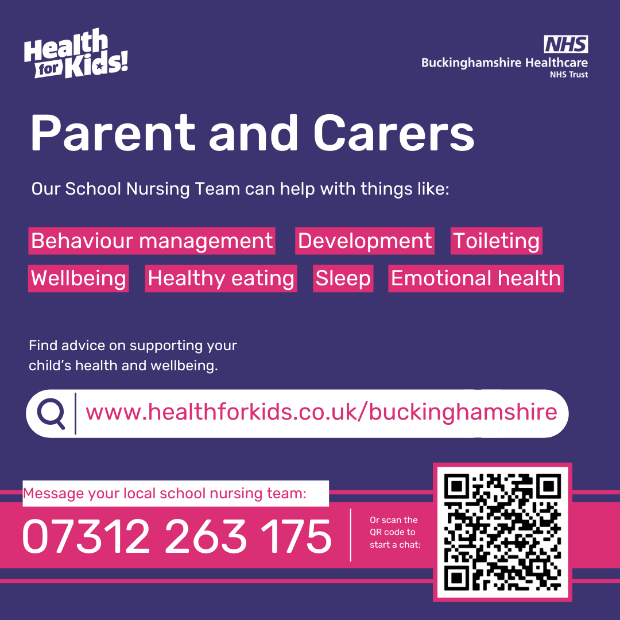

Pre-school News
Thank you to everyone who came to our Easter event on Easter Monday, valuable funds were raised towards our new building.
If you would like to register your child for a space at Padbury Pre-school please get in touch with Claire McHenry theark@padburypreschool.co.uk for more information. We have a few spaces during the summer term and are already taking registrations for September 2026 and beyond.

PFA News
A massive THANK YOU to everyone who supported our Easter Raffle at school and our Guess the name of the bunny at pre-school, lots of prizes were won and £408 was raised which is an incredible amount.

This Saturday 18th April from 10am please join us at school to help us to tidy up and sort out our PFA shed. Refreshments will be available. Lots of hands make light work.
On Friday 24th April from 3pm we will be having our watermelon and strawberry sale £1 each in the parent waiting area. Children who go home on the bus or to after school club will be able to come out before the end of the school day with a member of school staff to make a purchase. Payment can be made in cash, by bacs or card.

going towards the pre-school new building fund. We are really excited about the changes happening at pre-school over the coming months in terms of changing and improving our facilities.

Diary Dates
Please find below a table of events for the year. I hope you find these useful. There may need to be changes of dates as we move through the year but hopefully, where we can, these dates will remain. Please note the two INSET days in January and June. All term dates can be found on our website.

Lucy McFarlane
Headteacher

Activity | Date | Information
April
PFA Watermelon & Strawberry Sale | 24th | 3pm in parents waiting area
Oak class swimming starts at Swan Pool | 29th | Please refer to letter sent to Oak class
May
SATS week | w/c 11th | Year 6 SATS
Last Day to order Leavers Hoodies | 22nd | Year 6 Leavers Hoodies. Please order from Rio Workwear
Children break up for half term & PFA Fun Friday – more info to follow | 22nd | School finishes at 3.15pm
June
Inset Day | 1st | No children in school
Children back to school | 2nd | 2nd half of Summer term
PFA Ice cream sale | 12th | 3pm in parents waiting area
Class photos | 16th | Whole school class photos
Fathers/Carers Day celebration | 19th | Maple & Beech class – 2pm in school hall - more info to follow
PFA Ice cream sale | 26th | 3pm in parents waiting area
Sycamore class residential | 29th - 1st July | Visit to Whitemoor Lakes - more info to follow in January
July
Sycamore class performance | 9th | Sycamore class end of term performance - 2pm
Sports day – Coffee Van available & PFA Cake sale on the school field after lunch | 10th | Whole school Sports Day - 9.15am
Stolen Lines Band | 11th | Padbury village Hall
End of term service | Date & time to be confirmed
Last Day of Summer term | 21st | School finishes at 1.30pm

