
‘Shine as a light before others so that we can all be the best that we can be’ Matthew 5:14-16

At Padbury, we use the analogy of Windows, Mirrors and Doors to describe the process of turning a spiritual moment into an opportunity for spiritual growth
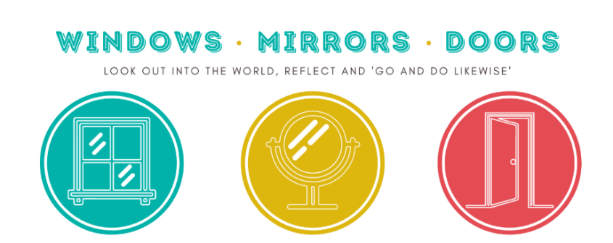

Windows | Mirrors | Doors
Beauty  Like looking through a window.  Windows – Learning about life | Self  Like looking in a mirror  Mirrors – Learning from life ​ | Others  Like opening a door to welcome people in  Doors – Learning to live life
Opportunities for children to be aware of the world in new ways, looking out into the world. ​  To wonder about life's 'WOWS.' Things that are amazing. ​  To think about life's 'OWS' that take us by surprise! ​  Learning about life in all its fullness. ​  We give children opportunities to become aware of the world in new ways; to wonder about life’s ‘Wows’ and ‘Ows’ (things that upset us and cause us to be uncertain). In this, our children are learning about life in all its fullness. | Opportunities to reflect on their experiences. ​  Looking inside yourself. ​  Consider life's big questions and reach for some possible answers. ​  Learning from life by exploring our own insights and those of others. ​  We give children opportunities to reflect on their experiences; to meditate and reflect on life’s big questions and to consider some possible answers. In this, they are learning from life by exploring their own insights and perspectives and those of others. | Opportunities for children to respond. ​  Moving onto a new path or situation. ​  To do something creative to develop and apply our ideas. ​  Learning to live out our beliefs and values. ​  We give children opportunity to respond to all of this; to do something creative as a means of expressing, applying and further developing their thoughts and convictions. In this they are learning to live by putting into action what they are coming to believe and value.
Spirituality within our Curriculum
At Padbury Church of England School, we promote spirituality though each curriculum subject area. Here are some examples of how we promote this across the curriculum areas.
Subject | How do we encourage spirituality across the curriculum?
Maths | - Children are engaged in deeper thinking with regards to problem solving.  - Identifying pattern and creating awe and wonder regarding numbers  - Exploring truth in terms of number  - Resilience when tackling tricky tasks  - Sense of achievement  - Creating confident learners  - Teaching children self-worth and encouraging them to take risks  - Identifying Maths concepts such as time and space
English | - Connecting our own lives to the characters in the text.  - English engages children with poetry, fiction and drama.  - It invites and encourages the children to explore feelings and values in a wide range of genres.  - Encourages confidence and self-belief through drama, speaking and listening activities.  - Understanding the world and others feelings through books and texts  - Developing compassion and understanding of others  - Understanding emotions through written words  - Having aspirations through inspiration in books and text  - Visiting other worlds through books and text  - Creating and idea of awe and wonder through literature  - Perseverance when writing/reading  - Sense of achievement  - Creating confident learners through developing reading and class discussions  - Teaching children self-worth and encouraging them to take risks
RE | - Learning about different spiritual beliefs around the world.  - Learning about spiritual practices around the world.  - Feeling confident to share our own spiritual beliefs.  - Explore a range of religions and explore ways that people worship, celebrate events and show that they are part of a community.  - Developing a sense of questioning the world around them  - Asking questions about faith and religion on a personal and wider level  - Use of music and art  - Worshipping  - Understanding other cultures, opinions, values and points of views  - Understanding many celebrations and beliefs  - Developing an understanding of commitment and sacrifice
Science | - Celebrating new life.  - Asking questions about science, religion and the world  - Having an awe and wonder about the various scientific concepts  - Discovering space, the universe and beyond  - Creating links and questions between science and religion  - Perseverance  - Creating awe and wonder across all age ranges through experiments and investigating.  - Raising aspirations of children through giving them awareness of science careers.
Computing | - Awe and wonder of what can be found on the internet  - Joy and excitement of what can be developed and created  - Communication with others and how to take responsibility for themselves online  - How can technology bring rapid benefits to discussions and tolerance of pupil’s beliefs?  - Children are exposed to the limitations and the abuse of the internet where they question and justify aims, values and principles of their own and other’s belief systems.
PE | - Working as a team  - Self-actualisation  - Caring, encouraging and supporting others  - Participating in sports teams to achieve a bigger goal  - Understanding failure and disappointment as well as success and joy  - Understand how to overcome challenges with determination and perseverance. Explain how confidence can effect performance.  - Identify ways of dealing with stress using physical activity.  - Recommend suitable activities for healthy lifestyle for different ages. Identify areas they are confident in.  - Understand that being healthy incorporates body, mind and lifestyle. Being gracious in success as well as defeat.  - Make links between balanced lifestyle and being happy.  - Understand a variety of tactics and strategies for different activities.
Creative Arts:  - Art  - D&T  - Music | - Creative thinking and innovation encourages the children to discover new talents.  - Builds self-confidence and belief in their own abilities.  - Encourages the use of creative instincts.  - Expressing their feelings through media.  - Exploring how art makes them feel and why. Creating art in the style of other  - Ability to be reflective about their own beliefs, religious or otherwise and use this to create and choose music.  - Sense of enjoyment and fascination in learning about themselves, others and the world around them.  - Use of imagination and creativity in their learning.  - Willingness to reflect on their experiences.  - Understanding the beauty in design and the world  - Personal achievement  - Perseverance  - Communication and working with others  - Problem solving  - Understanding how subjects such as art can have an emotional impact on the beholder  - Understanding the world and the way people treat each other in subjects such as history and geography  - Perseverance  - Resilience  - Achievement  - Self-exploration and an understanding of you as an individual  - Understanding other cultures, opinions, values and points of views  - Understanding of diversity  - Questioning the world and the environment
Geography | - The wow of physical geography.  - The ow of discovering different physical regions do not provide the same opportunities.  - Questions about the care of the environment  - Empathy with people from other parts of the world  - Promotes a sense of wonder and fascination with human and physical aspects of the world.  - Creating an understanding of scale- how small changes in climate can have far reaching consequences.  - Understand that all life in linked and creates the processes that make Earth the only habitable planet.
History | - Being in touch with past people, things and ideas  - Handling artefacts  - Influential events and people  - War and Peace  - Invention and exploration  - Encourages a sense of curiosity and mystery of how and why events happened. What would be different now if things had happened differently?  - Pupils are encouraged to explore the role played by important individuals, for good or ill, in the shaping of the world we live in.  - Pupils reflect on different interpretations of the past and how they have been arrived at.
Collective Worship | - Prayer  - Reflection  - Sharing collective worship  - Listening to stories  - Connecting together  - Sharing a multitude of emotions and feelings  - Empathy  - Awe and wonder  - Creating questions  - Encouraging self-exploration  - School values
PSHE | - Engage children with a range of mindfulness activities.  - Children explore a range of feelings and values across a range of situations and scenarios through role play, story-telling and discussions.
RSE | - Learning and understanding physical development at appropriate stages. Understanding human sexuality, reproduction, emotions and relationships.
Forest School | - Encourage, inspire and build upon independence, self-esteem and confidence through hands on learning experiences.  - Creating awe and wonder for all age groups in a new setting or environment.  - Creates respect and love for the environment.
Around the school | - Promoting self-responsibility for behaviour  - Caring for others inside school and on the playground  - Respect  - Kindness  - Thankfulness  - Manners  - Helpfulness

