

Padbury CE School Newsletter Autumn Term 2026

Issue 3 23rd September 2026

Our value this half term is ‘Love & Kindness.’
“Love is patient, love is kind."
1 Corinthians 13:4

Dear Parents and Carers,

School is now well and truly back in full swing, and I have been delighted to meet so many of you over the past few weeks. I have also had increasing opportunities to spend time in classrooms and with the children, getting to know them and seeing first-hand the excellent learning that is taking place across the school.
This week's newsletter is a little longer than usual, as there is a considerable amount of important information that I would like to draw to your attention. It also includes details of some changes to procedures and ways of working, which may differ from those in previous years.
Thank you for your continued support and partnership. I look forward to working with you throughout the year as we continue to provide the very best experiences and opportunities for all of our children.

Harvest Festival
On Friday 16th October at 2.00pm, we will be holding our Harvest Festival Service in the school hall. The service will last no longer than 30 minutes, and parents, carers, and family members are warmly invited to join us as we come together to celebrate the harvest season and give thanks for all we have. As part of our celebrations, we will once again be collecting donations for our local food bank. Donations can be brought into school from next Monday until Thursday 8th October. Any contribution, no matter how small, will make a real difference to families in our community, and we are extremely grateful for your generosity and support. We look forward to sharing this special occasion with you.

Open School and Book Look
Following the Harvest Festival on Friday 16th October, classrooms will be open from 2.30pm for parents and carers to visit and enjoy a look at the children's learning and achievements so far this year. This will be a wonderful opportunity to celebrate the hard work, progress and creativity of the children, as well as to gain a greater insight into life in the classroom. We are proud of all that our pupils accomplish and look forward to welcoming you into school to share their successes.
As a result, we will not be holding a separate book look alongside Parents' Evening this term.

Parents' Evening
Parents' Evening will take place on Wednesday 4th November and Thursday 5th November and appointments will be available to book through MCAS (My Child at school) by Friday 2nd October. We will send an email out to let you know when this is live. For any new parents, please ensure that you have signed up to MCAS to ensure that you can book a slot. Please contact the school office if you require any assistance with this.
We value the importance of strong home-school partnerships and look forward to welcoming you to discuss your child's learning, progress and wellbeing.
This year, the format will be slightly different. All class teachers will be based in the school hall, making it easier for parents to move between appointments. Consultations will last for 10 minutes, with a bell ringing after 9 minutes to provide a gentle reminder that the session is coming to an end and to help ensure that appointments run smoothly for everyone.
In addition, teachers will not be producing mid-term written reports this year. Instead, we are placing greater emphasis on meaningful face-to-face conversations, giving parents and carers the opportunity to celebrate achievements, ask questions, and discuss next steps in their child's learning. We believe this approach will provide a more personal and valuable opportunity to work together in support of every child.
We look forward to meeting with you.

SEND Support Plans
SEND Support Plans will be emailed to parents towards the end of this half term once I have completed a thorough review of all plans.
If you have any questions, concerns or would like to discuss the support your child receives, please speak with your child's class teacher during Parents' Evening. This will provide an opportunity to review progress, discuss current provision and consider any future steps to ensure your child continues to flourish both academically and personally.
Thank you for your continued support and partnership as we work together to help every child achieve their full potential.

Behaviour Information Meeting
I will be holding a Behaviour Information Meeting towards the end of this half term, with the date to be confirmed shortly.
The meeting will take place straight after school pick up in the school hall and will provide an opportunity for me to share our revised behaviour policy and procedures. My aim is to ensure that all parents feel informed, reassured and confident in the approaches we have in place to promote a positive, respectful and successful learning environment for every child.
I appreciate that attending meetings after school can sometimes be challenging for families. To help make the meeting as accessible as possible, I am currently working with S4A to provide childcare during the session. I am delighted to be able to offer this provision free of charge, allowing more parents and carers to attend. Once the date has been confirmed, please contact the school office if you would like to make use of this support.
Please note that this meeting will focus on our whole-school approach and will not be a forum for discussing individual children. If you have any concerns regarding your child, your child's class teacher should always be your first point of contact.
I look forward to meeting with you and continuing to strengthen the partnership between home and school.

Communication
Clear and effective communication is essential in building strong relationships between home and school. To support this, I have produced a "Who to Contact" guide, which outlines the most appropriate person to contact for different questions, concerns or areas of support.
I hope this guide helps families feel confident about who to approach and enables us to respond to enquiries as efficiently as possible. By working together and following these communication pathways, we can ensure that every child receives the best possible support.

We are proud of the positive relationships we have with our families and value open communication between home and school. We kindly ask all parents and carers to ensure that conversations and communications with staff are always courteous, respectful and polite.
We understand that questions, concerns and differing viewpoints may arise from time to time, and we are committed to listening and working together to find solutions. By communicating in a constructive and respectful manner, we can maintain a positive partnership that supports the wellbeing and success of all our children. Thank you for your continued support and cooperation.

Toys from home
Just a reminder that no toys should be coming in from home. We have noticed that children are bringing them in and then get very distressed when the get lost.

Healthy Snacks
A gentle reminder that we are a healthy school, and we encourage all packed lunches and break-time snacks to reflect our commitment to healthy lifestyles and wellbeing.
As in previous years, we kindly ask that sweets and party bags are not brought into school to celebrate birthdays. While we recognise how special birthdays are for children, we want to ensure that celebrations remain inclusive for all pupils and are in keeping with our healthy school values.
We greatly appreciate your support with this. If your child would like to celebrate their birthday in school, please speak with their class teacher, who will be happy to discuss alternative ways to mark the occasion.

PE Kits for Beech Class
Following a review of our arrangements, we have decided that children in Beech Class may come to school wearing their PE kit on their designated PE days which are Monday and Tuesday
We hope this will make the school day a little easier for children and families, while also maximising learning time by reducing the need for changing during the school day.
Please ensure that PE kit remains in line with the school's uniform expectations and is suitable for the weather on the day.

PE Lessons
Children will have PE in the afternoons as follows:
Maple – Monday and Wednesday
Beech – Monday and Tuesday
Oak – Wednesday and Thursday
Sycamore – Tuesday and Thursday

Car issues in Lower Way.
Thank you to those parents who are parking with care and consideration of those living in Lower Way. There are however some issues which have been brought to our attention that are quite dangerous and are against the Highway Code. Can drivers please be mindful of their speed when entering Lower Way from Main Street in Padbury, there are no footpaths on Lower Way so children and adults use this road to walk up to school, cars should be passing slowly.
From the A413 Lower Way is a no entry road you cannot drive and park at the top facing down the road and once you have dropped off your child reverse back onto the A413. Parking here not only blocks the view for anyone trying to get out of an already difficult junction but is an accident waiting to happen as you reverse back out onto a busy main road.
Parking is available in the Springfields Pavillion Car Park also known as the Football Car Park.

Maple Class
Thank you to everyone who attended the meeting today. We appreciate your time and support. For those who were unable to attend, an information pack will be coming home today so that you have access to all the key information discussed. Please feel free to contact us if you have any questions or would like any further clarification.

SENDco and Safeguarding email addresses
Please be reminded that if you would like to get in touch with the school SENDco or have any safeguarding concerns, please email directly to the following email address:
SENDco - sendco@pdb.odbst.org
Safeguarding – safeguarding@pdb.odbst.org

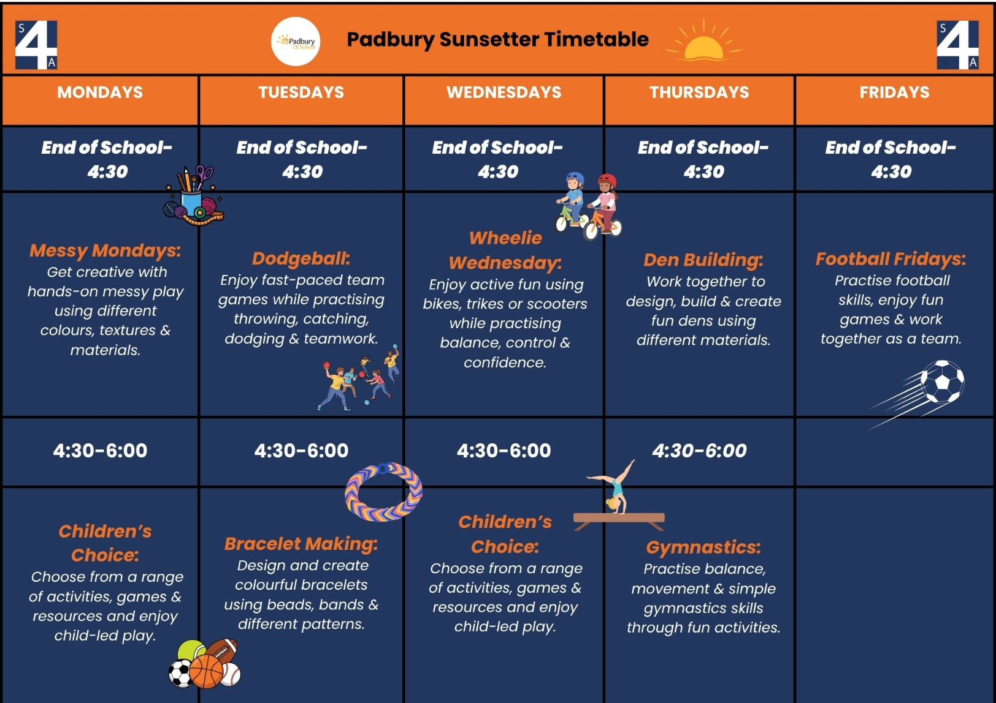
Dear Parents and Carers,
What would your child choose after school?
Getting stuck into messy play? 🎨 Racing around on bikes and scooters? 🚲 Building a den with friends? ⛺ Or finishing the week with football? ⚽
At Padbury CE School, S4A Wraparound Care gives children something different to enjoy throughout the week, helping the time around the school day feel like something they can genuinely look forward to.

🌅 A positive start to the morning
Our Breakfast Club gives children the chance to enjoy a nutritious breakfast 🍎, spend time with friends and take part in games and activities before lessons begin.
Alongside quieter choices, there are opportunities for movement and active play, helping children start the day feeling settled, engaged and ready for the morning ahead.

☀️ What’s happening after school?
There’s something different to look forward to each day:
🎨 Monday – Messy Mondays
Children can get creative with hands-on messy play using different colours, textures and materials. Later, they can enjoy Children’s Choice, picking from a range of games, activities and resources.
🔴 Tuesday – Dodgeball & Bracelet Making
Get active with fast-paced Dodgeball, practising throwing, catching, dodging and teamwork. Later, children can slow things down and design colourful Bracelets 🌈 using beads, bands and different patterns.
🚲 Wednesday – Wheelie Wednesday
A chance to get active using bikes, trikes or scooters, while practising balance, control and confidence. Later, children can choose how they want to spend their time through Children’s Choice.
⛺ Thursday – Den Building & Gymnastics
Children can work together to design and build their own dens, using different materials and plenty of imagination. Later, they can practise balance and movement through fun Gymnastics 🤸 activities.
⚽ Friday – Football Fridays
Finish the week with football skills, games and teamwork — a simple but fun way to round off the school week with friends.

💙 Different days, different reasons to stay
Some children love getting active. Others enjoy creating, building or choosing their own activity.
That’s why the Padbury timetable gives children a mix of movement, creativity, teamwork and child-led play, helping Wraparound Care feel like an enjoyable part of the day, not just somewhere to wait until home time.
For parents, it also means having a familiar and flexible option available around the school day whenever it works for your family.

🔎 Explore Padbury Wraparound Care
You can view session information, booking options and make a booking through the Padbury S4A page.
https://www.s4aclub.co.uk/school/padbury/
If you have any questions, please contact us at 01280 460560 or info@s4aclub.co.uk.
We look forward to welcoming your child 😊
The S4A Team

Dates for Your Diary
Calendar of Events 2026
Activity | Date | Information
September
Children have been challenged to raise for £20.26 | 21st | See PFA news for more info
EYFS curriculum workshops | 30th | Maple Class - 8.50am
October
PFA Disco – whole school | 9th | See PFA news for more info
Open Morning - for Sept 27 admissions | 15th | 9.30am
Harvest Festival – whole school | 16th | 2pm – School Hall
Book Look – whole school | 16th | After the Harvest Festival service
School breaks up for half term | 16th | Normal time
November
Children return to school | 2nd | 2nd half of Autumn term
Open Morning - for Sept 27 admissions | 3rd | 9.30am
Parents Evening | 4th | 3.30pm - 7pm – Pre loved uniform will be for sale
Parents Evening | 5th | 3.30pm - 5.30pm – Pre loved uniform will be for sale
Individual School photos | 12th | Whole school - children only
Flu Clinic | 20th | Whole school - more info to follow
PFA – AGM meeting | 24th | Come along to Padbury School Hall and celebrate the past year with the PFA and make plans for next year. Refreshments will be provided
PFA - Christmas Festival | 28th | Selection of stalls, refreshments, raffle, tombola – 11am – 2pm
December
Open Morning - for Sept 27 admissions | 2nd | 9.30am
Christmas Float | 5th | Join the PFA to collect money with the Rotary float
PFA – Wreath or table decorating evening | 8th | Enjoy a mulled wine at the Blackbird in Padbury while making a wreath or table decoration
Maple & Beech class Nativity | 8th | more info to follow
Maple & Beech class Nativity | 10th | more info to follow
Elfridges – whole school | 11th | More info to follow
Christmas lunch at school | 16th | Please order directly through Chartwells
End of Term Service | 17th | time and location tba
End of Term | 18th | School finishes at 1.30pm

Emma Gooding
Head of School

PFA News

Thank you to everyone who came along to the Welcome Back BBQ, it was a great social event which thanks to your generousity raised £205.39 We welcome Mayra (Alfie in Maple's mum) who joined the PFA committee at the event.

Your child may have come home the other day talking about doing jobs or baking cakes and being paid to do it. Our 2026 Challenge was launched in assembly on Monday. We challenge every child to raise £20.26, we are aware some may raise less and others more. They may do a sponsored silence for 26 minutes!!! Read 26 books or complete a sponsored bike ride or swim, score goals in their football or clear away the plates after a meal. Your child has until 16th October to raise as much money as they can. Money can be transferred into the PFA account or brought into school in an envelope and dropped into the office or the PFA postbox.

On Friday 9th October we have organised DJ Carl to return to play his tunes as we all show off our best moves on the dance floor. The event will take place in the school hall. Maple and Beech Disco will take place from 4-5pm, parents can drop their children off and return to collect at 5pm, for a cost of £5, for which they will receive snacks (crisps and a packet of sweets).
Oak and Sycamore will be able to impress each other with their dance moves from 5:15-6:15pm, for a cost of £4. Please remember to send your child with tuck shop money.
Disco places can be booked by transferring your money into the PFA account with your child’s name & disco as reference eg: ClaireM/Disco

The PFA Bank details are:
Lloyds Bank
Account name: Padbury PFA
Sort code: 30-91-39
Account number: 00222783

